## Install and Configure Visual Studio Code for HTML

1. **Start** with Visual Studio Code.
2. Create and select the **working folder** in which we will create our first HTML page.

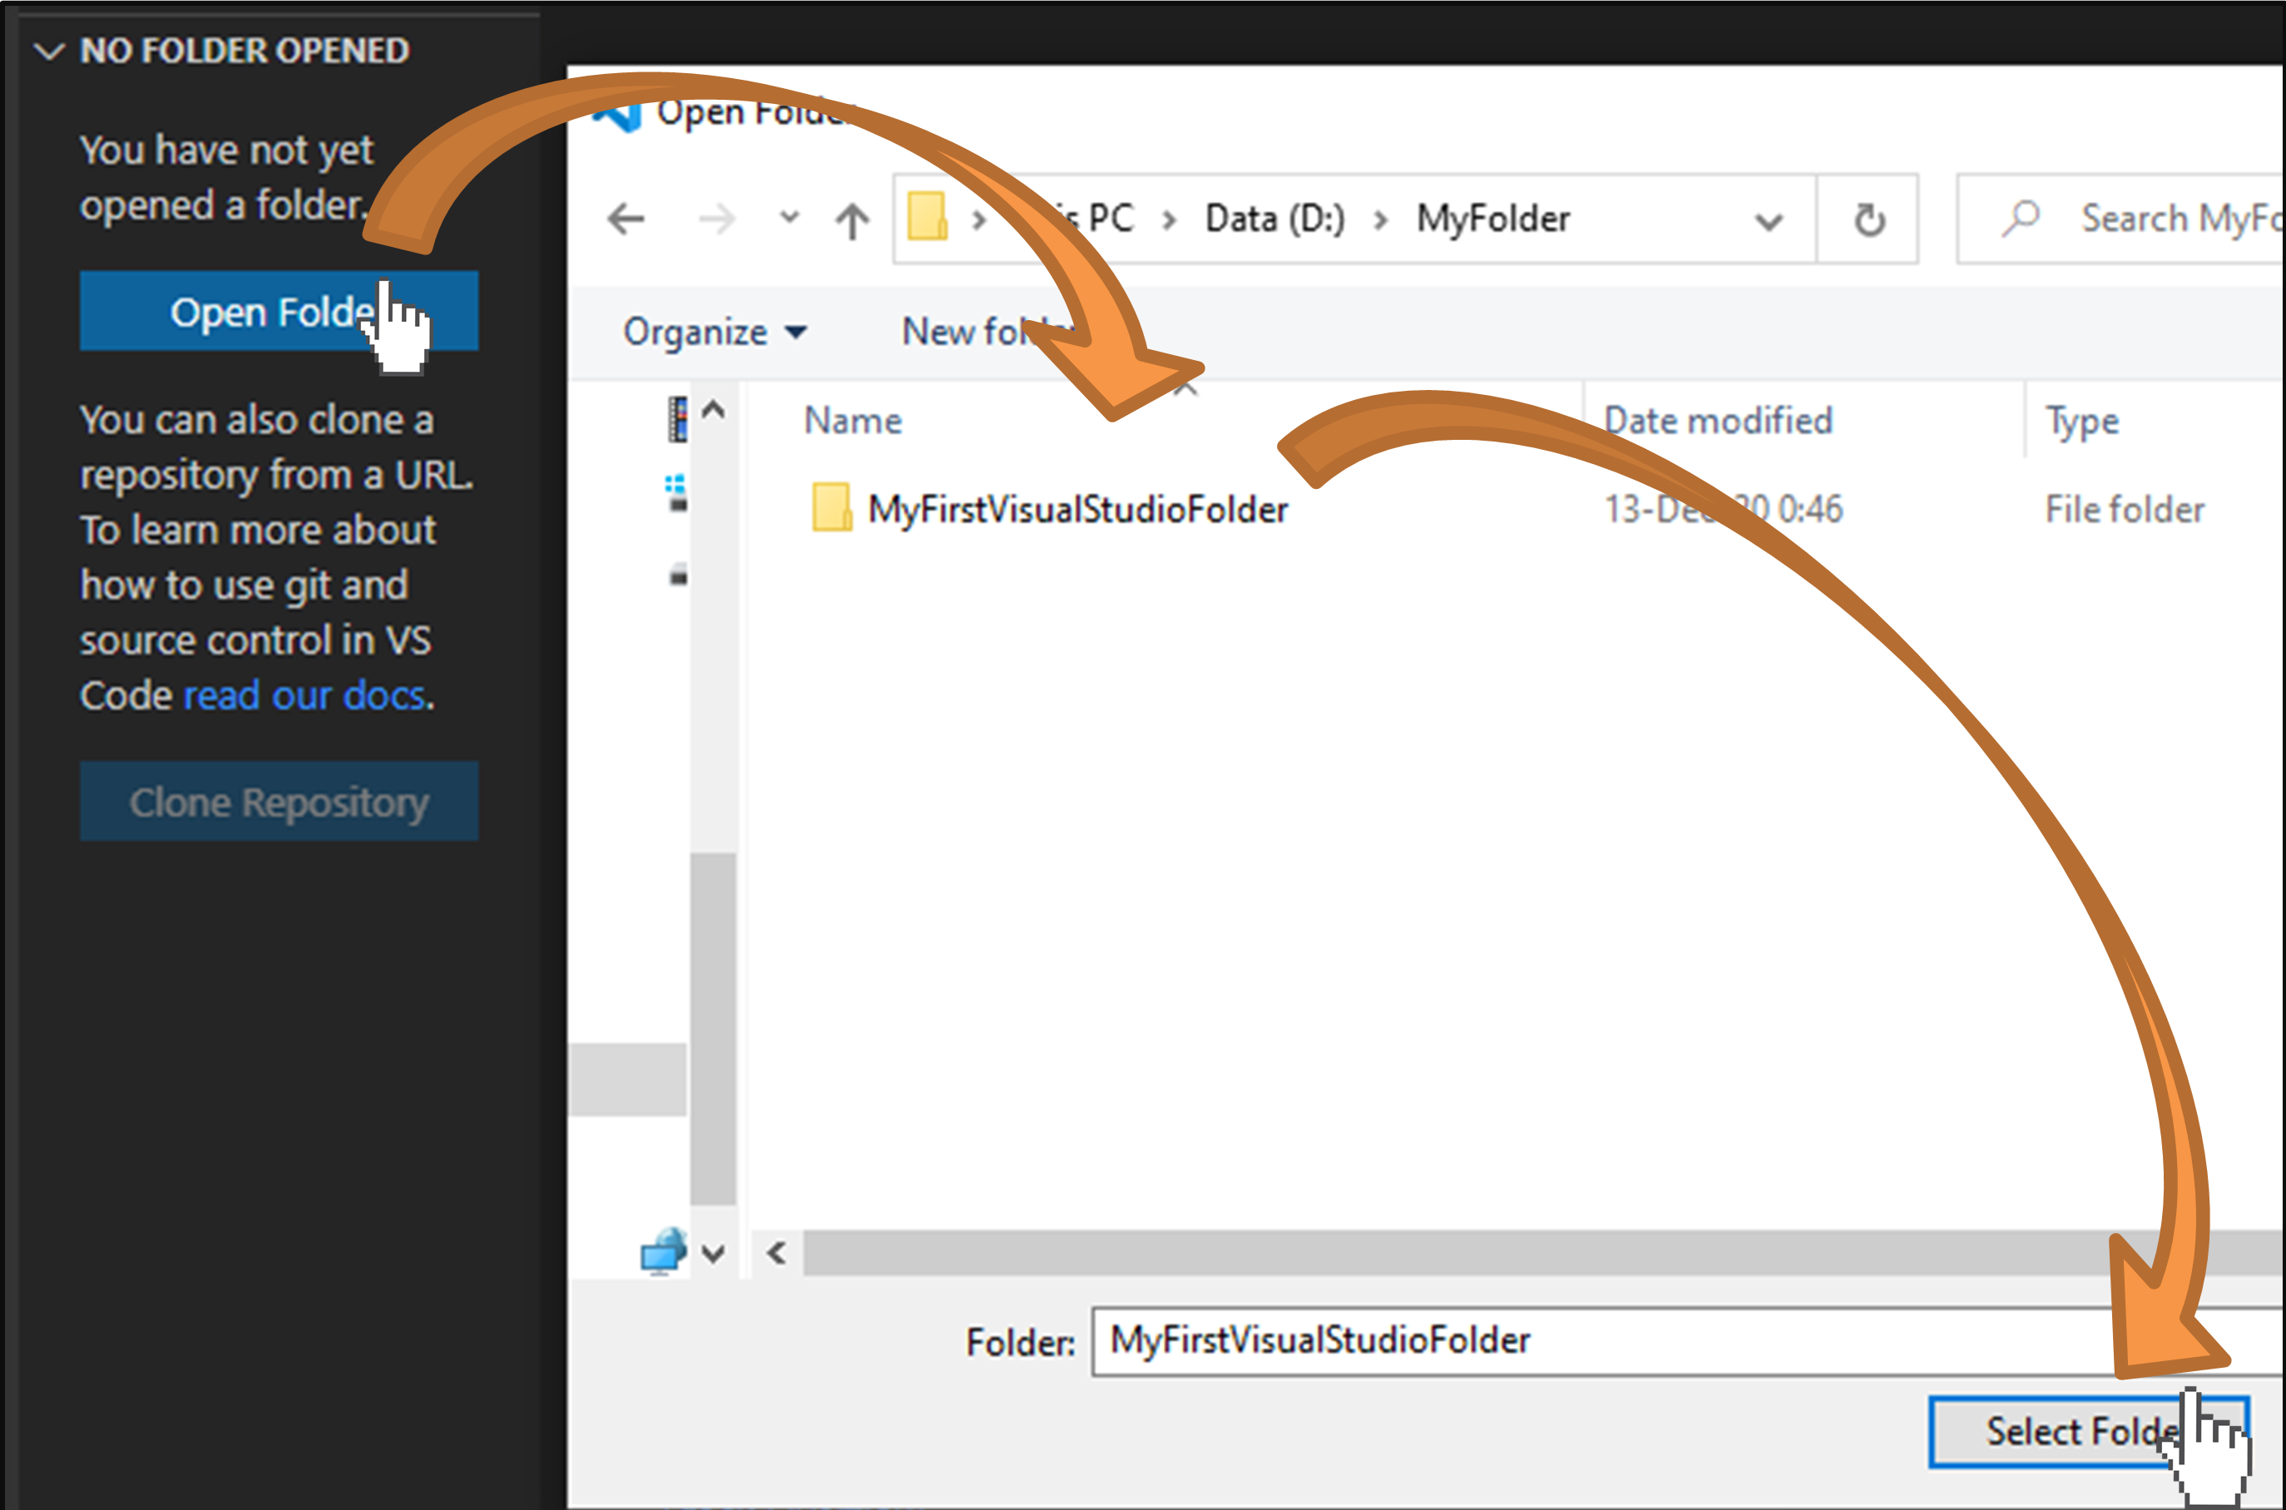

1. Create a new **HTML file**:

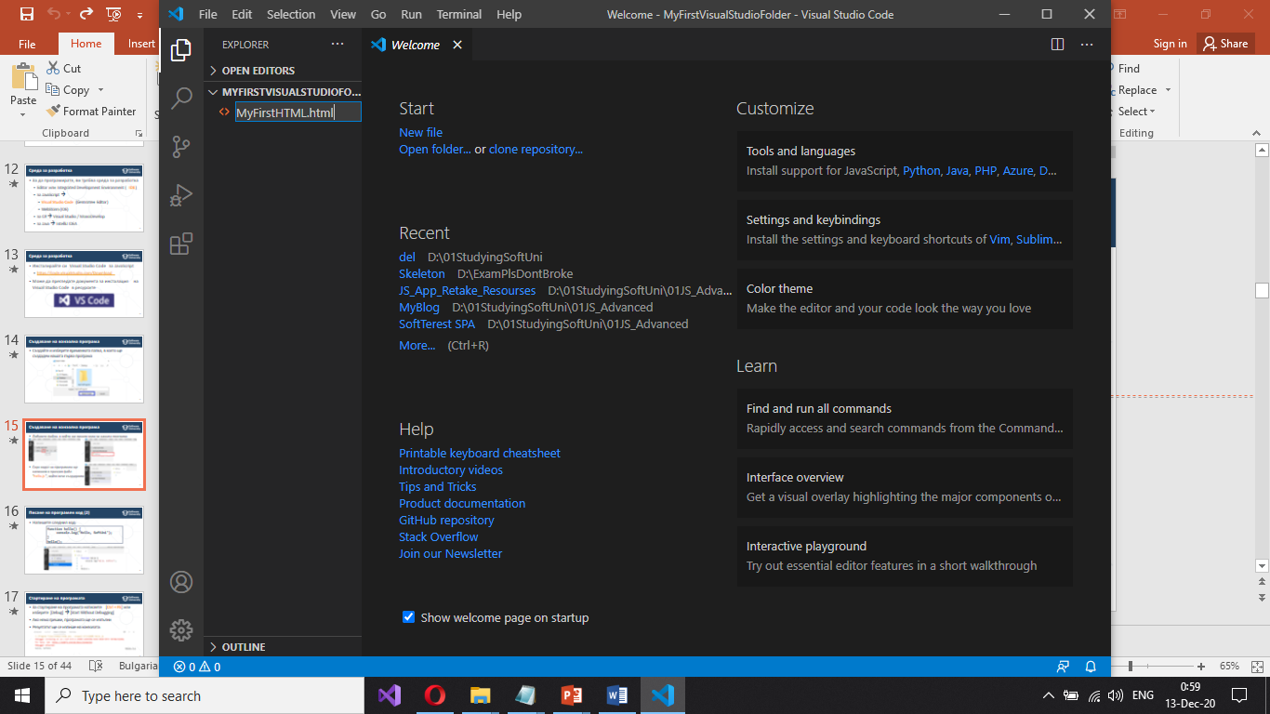

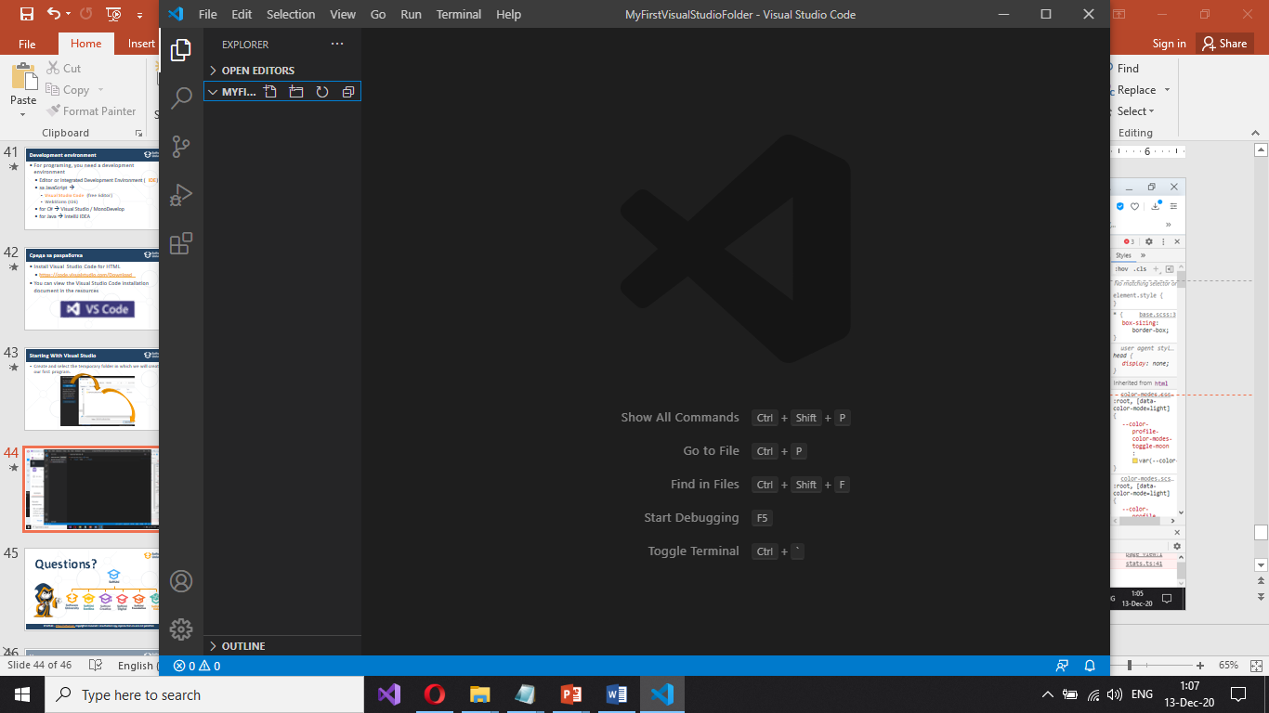

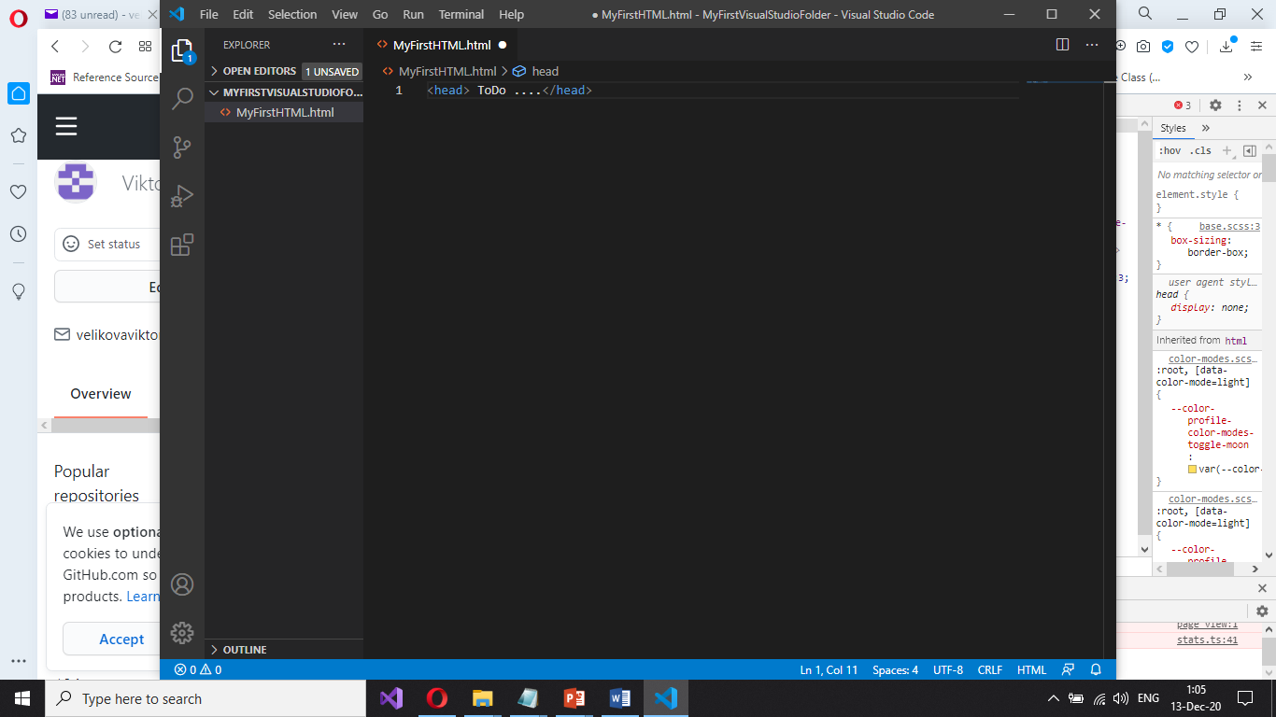

1. Install the **extension** “Live Server”:

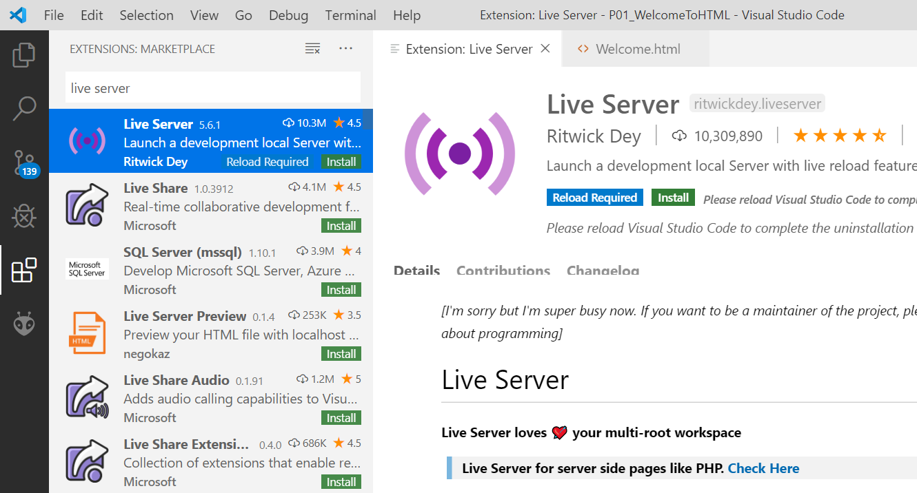

1. Тo see the result of the written code in a browser, **right-click** on the project and select [**Open with Live Server**].

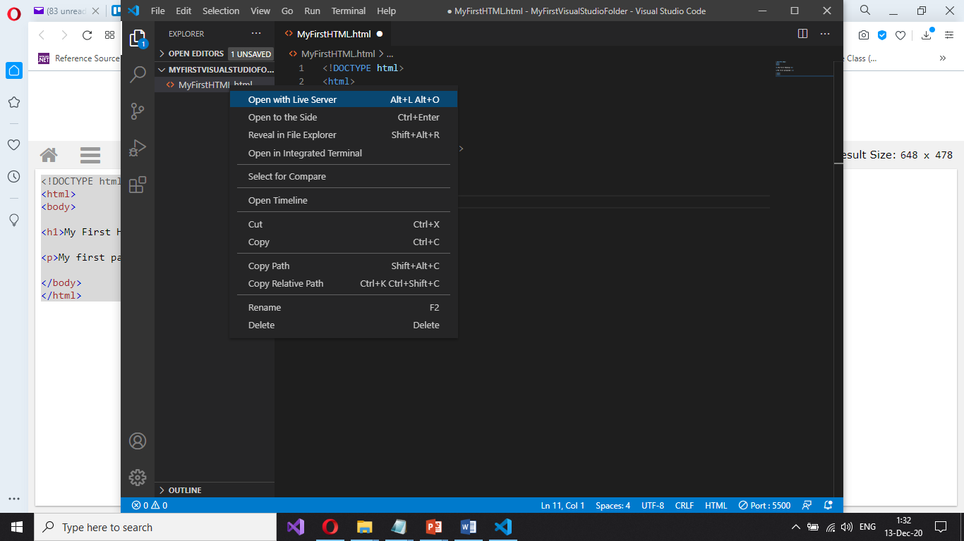

You will see the output from your HTML code in the Web browser:

